**Installing Finiflux2.0 (Finite element method for quantifying groundwater fluxes to streams using Radon)**

By Ben Gilfedder and Sven Frei

*Limnological Research Station & Department of Hydrology, University of Bayreuth, Universitätsstrasse 30, 95447 Bayreuth, Germany*

Please also see the paper: Technical Note: FINIFLUX an implicit Finite Element model for quantification of groundwater fluxes and hyporheic exchange in streams and rivers using Radon in Water Resources Research 2015.

There are two main parts of Finiflux2.0. The first is the optimisation program BEOPEST (Watermark Numerical Computing, Principia Mathematica) and the second is the finite element model its-self. BEOPEST is an .exe file and is downloaded directly in the FINIFLUX ZIP folder. It does not need to be installed, it just needs to be located in the main folder being used for the simulations (this is also the default setting and nothing needs to be changed). The finite element model that calculates Rn activities is based on certain input parameters (e.g. groundwater discharge rates, hyporheic exchange, atmospheric exchange) and has been written and compiled in MATLAB-2015b on a 64 bit computer. This has certain advantages and disadvantages. The two most annoying things about MATLAB compiled programs is that (1) the .dll files (and maybe other things too) differ with every version released (e.g. 2014a, 2014b and 2015b are not compatible), and because of this (2) downloaded .dll packages are large (~700MB) despite our actual program being very small. The user has two options:

1. **Easy option** and for those **without a MATLAB licence**: Simply download and install our program compiled with version 2015b. Make sure you check whether you have a 64-bit computer otherwise FINIFLUX won’t work. The downloaded folder contains everything you will need to install FINIFLUX2.0 on your computer and to run the model and the graphing program. Method 1 to install FINIFLUX2.0:
   1. Make sure you have an internet connection.
   2. Run (double-click) the program ‘Instal_Finiflux.exe’. The program will download the required Matlab files to run. This is about 700MB, and will take some time, depending on your internet connection.
   3. Click through the menus. We recommend installing the files in the locations suggested by Matlab, but you can also experiment with other locations.
   4. Proceed to the manual of how to run the model.

**We have recently encountered problems with installing FINIFLUX this way. For some reason we have had trouble connecting to the matlab server and get this error:**

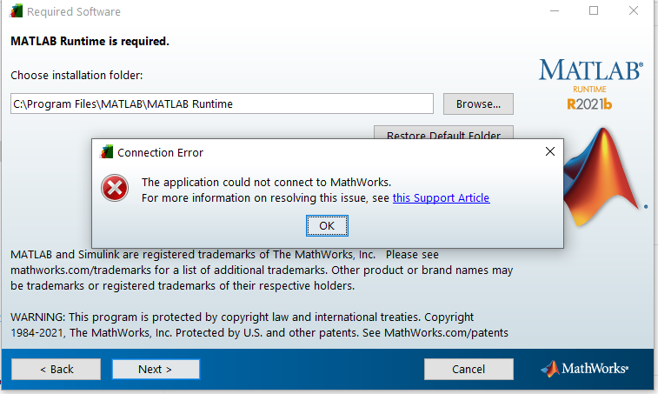

The second method is to go to the matlab runtime internet site and download the correct runtime containing all the correct .dlls. You can either search (e.g. google) ‘Matlab runtimes’ or follow this link:

<https://www.mathworks.com/products/compiler/matlab-runtime.html>

Download and install the runtimes for matlab **2015b (should be runtime 9.0)**. After this progress to using FINIFLUX.

1. If your have MATLAB and the MATLAB compiler app (deployment tool) you can compile our finiflux.m scrip into an .exe and use the dlls from your matlab version to run the program. We have less experience with this option, having only tried it on MATLAB 2014a, 2014b, 2015a and 2015a (out of necessity!) but so far it has worked. The steps are as follows:
   1. Open the script file ‘finiflux.m’ in your version of MATLAB, which is found with the source code folder
   2. Compile the program using the application compiler app. You must call the program finiflux
   3. Locate the folders containing your compiled model (they often open automatically). Go in to the folder ‘for testing’ and copy the finiflux.exe file. Paste this into your main directory if you have not as yet run the PRE_PEST set-up, or into the slaves if you have already run the set-up. Overwrite the existing finiflux.exe files. Proceed with the manual on how to run the model.
   4. If you intend to use our quick graphing program and the pest_tracker program you will also need to compile these. We find pest_tracker useful, but you should graph your own data at the end since the quick graphing program does not produce nice looking plots.